Title of the abstract (Arial, 14 pt, bold, sentence case, single spaced, centered)

First A. Authorª, Second B. Author^{b} (Arial, 12 pt, italics, singled spaced, centered,
Presenting author underlined)

ªAffiliation of the A. Author
^{b}Affiliation of the B. Author (Arial, 10 pt, single spaced, centered)
Email of corresponding author: Arial, 10 pt, italics

Main text: Arial, 12 pt, single spaced. Top margin is 3.2 cm; all other margins (left, right, bottom) 2.5 cm.
The references should be cited in the text in square brackets and the added after the text using the format below [1]. Figures and schemes may be included in the text (centered). They should be cited in the text (Figure x or Scheme x). Each figure should have a caption in Arial, 10 pt, single spaced, centered.

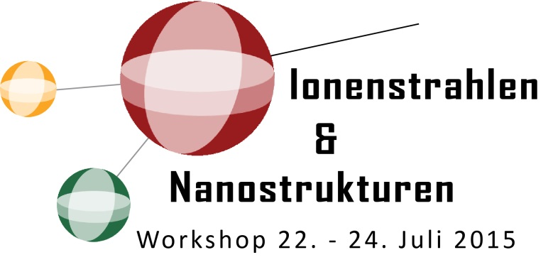
Figure 1. Workshop-Logo of ‘Ionenstrahlen & Nanostrukturen’.

THE DOCUMENT MUST NOT BE LONGER THAN ONE A4 PAGE!

Please follow closely the instructions in this template, since the abstract will be reproduced exactly as submitted.

Please submit the abstract as a pdf file.

Acknowledgements. (Arial, 10 pt, single spaced)

[1] X. Surname, Y. Surname, J. Amer. Chem. Soc. Year, volume, page. (Arial, 10 pt, single spaced)

